4th Annual News Letter
May 2021

Content:

  - Editorial – A reflection as the project concludes and a look ahead to the future
  - Published papers –
    - Deliverable 6.11 .Policy Briefs
  - Food News – A selection of more recent legume related releases in the food market
  - Major players in the pea protein isolate sector – directions to a report on industry developments and the market
  - PUBLICATIONS from the LEGVALUE PROJECT
  - WEBSITE RESOURCES – An outline of website content and resources development
  - COUNTRY ROUND UP – News and activities reported in partner countries.
    - Latvia
    - Germany
    - France
    - UK
    - The Netherlands
    - Denmark
    - Switzerland
  - CROP DIVERSIFICATION CLUSTER – Summary of activities and project status in the CDC
  - FINAL CONFERENCE – Delivery and content of the Final project Conference
  - LEGUME INNOVATION NETWORK – Your invitation to get in volved in the future
  - EIP PRACTICE ABSTRACTS – What they are and where to find them

Editorial

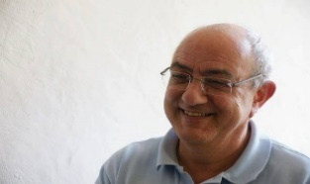
The LegValue project is coming to an end after 4 years of studies that have produced many results, some of which were highlighted during the series of webinars held between 14 March and 11 May this year. Most of these results are feeding the knowledge of actors involved in value chains which develop the production and consumption of pulses.
We had perceived a slight tremor when the project was set up, and we are happy to note today a growing number of new initiatives around legumes, mostly driven by innovations in all sectors of the value chain: varietal innovation, crop management, technological innovations in the processing that create value, and finally the beginnings of market organisation.
LegValue has produced tools and knowledge that should be developed further and maintained to ensure their availability for exploitation by all economic actors.
It is to this end that we are supporting, with the TRUE project, and our combined multi-stakeholder networks, the creation of the ‘Legume Innovation Network’, or ‘LIN’. The LIN aims to support and connect the large and diverse array of business communities which span the various legume-based value chains.
The capacities and success of the LIN will be determined by the goodwill and effort of those actors who engage and help ensure its utility and positive impact for businesses, and we can be assured that the EC offers favourable contexts for LIN initiative via the Green Deal, Farm-to-Fork, and new CAP.
I hope you enjoy the content and exploring the links provided in this final project Newsletter.
Frederic Muel (Teres Innovia) ( Legvalue Project Coordiantor)
Co -Editors:
Roger Vickers (PGRO)

Pete Iannetta (JHI) ( True project coodinator)

PUBLISHED PAPERS

Integrated policy analysis to identify transformation paths to more sustainable legume-based food and feed value-chains in Europe:

Summary:
The food- and feed-value systems in the European Union are not protein self-sufficient. Despite their potential to improve the well-being of arable cropping systems, sufficient production of high-protein legume grains in Europe has not been achieved due to multiple barriers. The reasons are multiple and span economic, agronomic, research, and extension services, as well as aspects of culture and traditional dietary habits. Given the well-documented advantages of legume-supported production systems and diets, that include ecosystem and health provisions, acknowledging and promoting legumes as cornerstone species for more sustainable agri-food systems is a necessary and logical step. This paper provides an integrated analysis of case studies and current policies that shape the production and consumption of legumes in Europe. This study identified three key pathways, which can be integrated into sustainable farming systems to support current and future food security challenges via the use of legumes and legume-based products. At each pathway, we identified several enablers that support the sustainability transformation of legume production and consumption in Europe.

https://www.tandfonline.com/doi/full/10.1080/21683565.2021.1884165

Deliverable 6.11
Final report on knowledge transfer activities for policy makers
Deliverable leader: UNIBO

Summary
The outcome of the Task 6.6 provides the evidence base for analyzing the policy instruments and measures that may influence the development of sustainable legume-based cropping and grassland systems and agri-food and feed chains. A series of 4 policy briefs has been produced in order to identify improved practical policy options to develop sustainable and competitive legume-based farming systems and agri-feed and food chains in the EU. Specific objectives were to perform a diagnostic of relevant policies affecting legumes and understand the effect of current policy settings at EU and national levels, to identify potential policy needs, to simulate selected alternative policy design options, and to iIdentify good practices and recommendations on prospective policy measures. Specifically, the Task 6.6 - Knowledge transfer for policy makers (M13-M48) is described in the DoA as follows: A minimum of 4 policy briefs will be produced drawing on the expertise of selected project partners and with the contributions from key Stakeholders. Policy briefs will consider the roles and responsibilities of different policy makers (EU, national, regional) and actors (research institutes, farmers, industry), the policy instruments and measures that may influence the development of sustainable legume-based cropping and grassland systems and agri-food and feed chains. For each policy brief a specific audience will be defined and the content tailored accordingly. A section in the Final Conference will be dedicated to policy engagement, targeting EC officers and policymakers.

Policy Brief 1

Short title: Analysis of relevant policy instruments and their effects on legume cultivation in EU

To incentivize European legume production, a range of different EU and national policies have been introduced. These include CAP measures and other individual policies such as Environmental, Food, Health and Energy policies: each Member State has the possibility to provide payments coupled with the cultivation of legume crops, to cultivate legume crops within Ecological Focus Areas (EFAs), or to provide subsidies for the implementation of agro-ecological schemes that include the cultivation of legumes. The aim of the study was to review the policies affecting legumes and analyze their impact. The diagnostic approach involved holding seven national workshops designed to gather expert views on the influence of current EU and national level policies. This analysis provided an understanding of the national and EU level contexts within which legume related policies were both designed and implemented. The policy environment for agriculture in the EU is complex, comprising a mix of regulatory, advice and incentive interventions. These are implemented mainly on a common basis but with a degree of flexibility both between and within Member States. CAP Pillar 1 Greening as an EU level policy was determined to have a positive impact on the volume of legumes produced in each Member State. Of course, the policy dependent nature of this effect also implies that any gains made would largely be lost if the policy instrument were to be removed. This dependency on public funding is not a sustainable approach and demonstrates the necessity to consider the effectiveness of the overall policy framework for increasing legume production - area, yield and market development - at both an EU and Member state level. The results also highlighted the need for more explicit policies for research and innovation in the sector (varietal improvement). They also raised the issue of the impact of contradictory policy interactions (at both a national and EU level), and a lack of understanding of the wider opportunities associated with legume production (i.e. the eco-systemic role legume crops play for humanity and the environment).

Policy Brief 2

Short title: Identification of potential future policy needs and options

The CAP post 2020 has an increased focus on tackling climate change, protecting the environment and maintaining landscapes. A minimum 30% of Pillar 2 funding will be spent on climate and environment measures, while 40% of the CAP’s budget will contribute to climate action. Agricultural measures that promote a simultaneous reduction in nutrient leaching and carbon emissions, though already available, need to be improved in order to fit the new EU policy priority. Given that legumes play an important role in facing critical challenges like food security, mitigating climate change impacts from agriculture, and by delivering multiple services in line with sustainable criteria, legume focussed agricultural production can contribute to a number of the sustainability goals of the post 2020 CAP. To analyse the effects of different policy instruments and their contribution towards increasing the production of legumes in Europe, a framework has been developed, based on a series of workshops with input and information from experts. The first round provided an understanding of the national and EU level contexts within which legume related policies were designed and implemented, whilst also helping to develop the evidence base for the second round. The objective of the second round was analyse how best to improve existing policies and instruments and identify additional levers for their development; as associated with the Farm to Fork and Biodiversity Strategies outlined in the European Green deal. The results highlighted a high degree of heterogeneity among the countries involved which reflected the need to focus European level policy ambitions towards more coherent strategic plans at national level. All countries tended to identify the production of legumes as an opportunity for society, the environment, and the wider economy. However, some regions were advanced than others. This may reflect the implementation of private and public policy mechanisms focused on stimulating demand rather than supply whilst also reflecting the degree of interaction between all actors within the value chain. It will be important to develop a strategic approach to policy which reflects regional contexts and demonstrates the added value of integrated legume value chains. Future policies will need to go beyond agriculture, combining health, environmental and food policy in a consistent policy strategy.

Policy Brief 3

Short title: Analysis of selected policy measures and alternative policy design options

One outcome of the LEGVALUE project is the recognition that legumes are affected by a complex set of policies acting often in an un-harmonized policy mix. To analyse most relevant policy instruments for the near future in the context of the project, a modelling exercise was carried outto support the evidence-based formulation of policies promoting legumes.
In a first step, a literature review was carried out that shows that policy modelling tools specifically related to legumes are not frequent in the literature. In most cases models address farm level decisions, simulating the impact of specific policy measures already in place (e.g., coupled payments). In some works, multiple indicators and multicriteria frameworks are used in order to account for environmental and ecological concerns linked to legumes cultivation.
LEGVALUE modelling activities concerned using simple land allocation models to understand farm level incentives and to design different policy options. They were further exploited in modelling future policy options concerning eco-schemes given that eco-schemes one of the most innovative parts of the CAP reform. Eco-schemes are annual payments for the uptake of voluntary measures related with environment, biodiversity, and climate change. In particular, a specific eco-scheme measure concerning the inclusion of legumes in rotation is considered.
In a first step, we modelled different farm types in Emilia Romagna (Italy) and simulated optimal crop mixes. In some cases, legumes are already cultivated in the farms, in others they were not. In a second step, a sensitivity analysis to the introduction of legume cultivation showed high heterogeneity among farms in the opportunity cost of dedicating a growing share of land to legumes. In a third step we searched for optimal design of eco-schemes, showing that simple eco-schemes measures may incur the well-known self-selection problem, with participation most likely among farmers that would probably cultivate legumes even without incentives. In these instances, the introduction of this measure will have very little impact. Differentiated payments may be needed to adapt incentives to different farm types. These need to be driven by a clear understanding of opportunity costs and environmental objectives, targeted by the instrument.

Policy Brief 4

Short title: Good practices and recommendations on prospective policy measures

The rising demand in the food and feed sector offers opportunities for legume production in the EU, but the sector still faces many challenges. These include a lack of economic competitiveness with other crops in most of regions in Europe. The knowledge required to grow legumes and the awareness of their positive impact on the following crop and on soil health in general needs to be increased and shared within the farming community. Alongside this increase in knowledge transfer and exchange, demand for legumes needs to be stimulated.
The last series of LegValue WP4 national workshops were designed to identify good practices and prospective policy measures for the promotion of legume production in the EU by gathering expert views across countries on the role of policy in providing incentives for legume production at the national and EU level. Feedback was gathered regarding the CAP, EU Strategy for Protein Crops, Farm to Fork Strategy and EU Biodiversity Strategy.
The current picture is characterized by the absence of a dedicated EU level legume policy. On the other hand, legumes are affected by several policy measures, mostly dedicated to more general aims, such as crop diversification or promotion of organic farming.
The outcome of the third round of workshops identified that the policy focus should be in the direction of supporting the development and strengthening of legumes value chains rather than simply supporting production with supply side payments. Innovation will have a central role in this context especially due to the need to provide higher technical efficiency and competitiveness for legume crops. The results from the workshops highlighted a high degree of heterogeneity among the countries involved, with a different focus of the policies currently in place or with a different degree of interaction between all actors within the value chain. One strategic issue is to set up appropriate coordination instruments among the main policy tools, to allow an appropriate and consistent policy mix to boost legume cultivation and production in the EU. It will be important to develop a strategic approach to policy which reflects regional contexts and demonstrates the added value of integrated legume value chains. And most importantly, there needs to be a coordination of the available and new policy instruments. In addition, a number of specific instruments are identified, including promotion of public procurement, producers’ organization, market information for companies and targeted support to internalize the environmental benefits linked to legume cultivation.

……………………………………………………………………………………………………………………………………………….

FOOD NEWS

Legume food and food ingredient related news items continue to flow almost daily. We have selected just a few appearing since our last newsletter.

Plant-based Food and Beverage Trends for 2021: Forecast growth of plant-based protein and meat alternatives is projected to increase reach $480.43 billion by 2024 by investment firm UBS. driven by rising concerns over the impact of our food choices on our health, sustainability, and animal welfare. https://tastingthefuture.com/2020/11/04/6-plant-based-food-and-beverage-trends-for-2021/

The drivers of product innovations in pulse-based foods: insights from twelve case studies of French and Italian firms that recently introduced new pulse-based foods in France, Italy, and the US.https://www.cairn.info/revue-journal-of-innovation-economics-2019-1-page-111.htm

Legume-based snacks: a great alternative to industrial products: A report in Food Navigator https://www.foodnavigator-usa.com/News/Promotional-Features/Legume-based-snacks-a-great-alternative-to-industrial-products
Plant-based ingredients are here to stay: Overview of integration across food and drink categories: A report by Food Ingredients Europe. https://www.figlobal.com/content/dam/Informa/figlobal/fieurope/en/2020/documents/HLN20FIE-GM-Plant-based-ingredients-are-here-to-stay.pdf
Agriculture focus: Legumes contribute to a better world. An Open Access Government article on the LegValue Project https://www.openaccessgovernment.org/legumes/88777/

Which trends offer opportunities or pose threats on the European grains, pulses and oilseeds market? CBI EU reporting https://www.cbi.eu/market-information/grains-pulses-oilseeds/trends

Statista report on Retail sales value of vegetable/plant-based protein meat substitutes in Western Europe in 2018, by category . Published by Nils-Gerrit Wunsch, Mar 23, 2020
https://www.statista.com/statistics/1076255/retail-sales-value-of-plant-based-meat-substitutes-in-western-europe-by-category/

Ingredion has expanded its range of plant-based ingredient solutions with the launch of its first-ever protein isolate. Derived from peas, the new protein isolate contains a minimum of 80% protein, supporting manufacturers in making front-of-pack claims.
https://www.ingredion.com/emea/en-uk/news-events/news/pea-protein-isolate-launch.html

Fairfield Market Research presents a detailed study about shift in dietary changes that are expected to boost the demand for pea protein ingredients
https://www.prnewswire.com/news-releases/environmental-concerns-and-healthier-lifestyle-boosts-demand-for-global-pea-protein-ingredient-globally-says-fairfield-market-research-301212430.html

Roquettes worlds largest pea protein plant marks ‘new era of food innovation’
https://www.foodnavigator.com/Article/2020/10/01/Roquette-s-world-s-largest-pea-protein-plant-marks-new-era-of-food-innovation

Pea Protein: Sowing the seeds for plant-based perfection:
https://www.foodnavigator.com/News/Promotional-Features/Pea-Protein-Sowing-the-seeds-for-plant-based-perfection

Pea protein: the next food safety scandal?
Thanks to its taste and texture, pea protein isolate is finding its way into a variety of vegan convenience foods, but as Nick Hughes reports, this popular ingredient comes with risks attached.
https://www.foodservicefootprint.com/pea-protein-the-next-food-safety-scandal/

Fava bean innovation opens new avenue for plant based product development:
https://www.foodnavigator.com/Article/2020/10/22/Fava-bean-innovation-opens-new-avenue-for-plant-based-product-development-We-are-thrilled-to-imagine-where-this-will-lead-us

Are the food ingredients of the future plant-based?
https://foodplatform.au.dk/news/nyhed/artikel/are-the-food-ingredients-of-the-future-plant-based/

Legumes research gets flexitarian pulses racing with farming guidance. Plant more bean-like crops in Europe and consider ‘healthy diet transition’ to beat climate crisis, say scientists
https://www.theguardian.com/environment/2021/apr/13/legumes-research-gets-flexitarian-pulses-racing-with-farming-guidance

……………………………………………………………………………………………………………………………………………….

MAJOR PLAYERS IN THE PEA PROTEIN ISOLATE SECTOR

In February 2021
https://www.marketsandmarkets.com/Market-Reports/plant-based-protein-market-14715651.html published a report Plant-based Protein Market (Published Date: Feb 2021 | Report Code: FB 7358)
The study outlines the rapidly developing market, the dynamics behind it and forecast rapid development in the period to 2026.
“the global plant-based protein market size is projected to grow from USD 10.3 billion in 2020 to USD 15.6 billion by 2026”. “This is attributed to the growing usage of pea protein in food industry and innovation in the technologies used for extraction of plant-based protein”
Key players in the plant-based protein market are identified to include DSM (Netherlands), ADM (US), DuPont (US), Kerry Group (Ireland), Cargill (US), Glanbia (Ireland), Wilmar International (Singapore), Emsland Group (Germany), Puris (US), Cosucra Group (Belgium), Batory Foods (US), Roquette Freres (France), Ingredion (US), Burcon Nutracience (Canada), Sotexpro (France), AGT Food & Ingredients (Canada), BENEO (Germany), Prolupin Gmbh (Germany), Aminola (Netherlands), Herblink Biotech Corporation (China), ET Chem (China), Shandong Jianyuan Group (China), The Green Labs LLC (US), and Parabel (US). These players have broad industry coverage and strong operational and financial strength.
……………………………………………………………………………………………………………………………………………….

PUBLICATIONS from the LEGVALUE PROJECT

A number of final reports and deliverables from the Legvalue project are currently classified as not for publications. The project management team is seeking permission from the EC to enable these reports to be released for public consumption.
When this permission is received, they will be published here: http://www.legvalue.eu/publications/
……..
Mapping achievable yield
In task 1.2, INRAE delivered the first version of the maps on the achievable yield of the 5 major pulse species considered in LegValue (i.e, soybean, field pea, faba bean, chickpea and lentils). The maps were produced through a data-driven approach based on the exploitation of the data present in the European Grain Legume Dataset (EGLD), an extensive dataset including more than 5000 yield data collected from published and non-published field experiments all over Europe ranging from 1973 to 2020. The EGLD was combined with a global climate dataset designed for crop modelling (JRA55-CDFDM-S14FD dataset). Crop yield was modelled as a function of 5 climate variables (minimum and maximum temperatures, rainfall, solar radiation, and reference evapotranspiration) defined at a monthly time step over crop-specific growing seasons. Growing seasons were defined based on observed sowing and harvest months in the EGLD, and winter and spring types were treated as separate crops for field pea, faba bean, chickpea and lentils. The model was fitted using a Random Forest algorithm. The model used revealed a good predictive ability with good agreement between predicted and observed yields under historical climate conditions (2000-2020). The maps revealed for many pulses a high suitability in different areas in Europe. The model has been validated in climatic conditions where the yield data were produced, and additional tests are necessary to define the model performances under new climatic conditions. INRAE is also working to add soil properties in the model (e.g., soil texture and pH) that could improve the model predictive ability in climatic conditions different from those used to calibrate the model. The final version of the maps is going to be delivered by the end of LegValue. Further steps will include using the model to estimate and map the effect of past and future climate change on legume yield. Such tool may represent an important support not only for scientists, but also for decision-making targeted to legume market operators, companies and policy makers." Contact nicolas.guilpart@agroparistech.fr
……..
Reporting on the Lentil value chain based on the PGI “Lenticchia di Altamura” (Alta Murgia, Italy)
https://www.youtube.com/watch?v=YOW1PFwr5cs
https://www.youtube.com/watch?v=jdaCmeoGbyY

with English subtitles*
​Elisa Lorenzetti
PhD candidate in Agrobiodiversity Scuola Superiore Sant'Anna; Office +39 050883569 ∞ Mobile +39 3383491734
……………………………………………………………………………………………………………………………………………….

WEBSITE RESOURCES

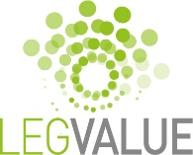
The project web site WWW.legvalue.eu has seen some development during the period with sections providing additional reports, background information and legume related output:
Resources : http://www.legvalue.eu/resource-section/

Educational resources: http://www.legvalue.eu/educational-resources/

European Breeding programmes: http://www.legvalue.eu/resource-section/european-pulse-breeding-programmes/

61 EIP- Agri practice abstracts have been produced throughout the duration of the project.
They have also been published on the project web site in the Resources section. http://www.legvalue.eu/resource-section/ . See section 11 below, for more details.

……………………………………………………………………………………………………………………………………………….

COUNTRY ROUND UP

News from LATVIA:
In January 2021 project partners Latvian Rural Advisory and Training Center ( LLKC ) held a conference "Grain legumes - from field to table". 500 farmer participants attended.

In the first part of the conference, it was possible to find out more about the LegValue project, the challenges and expected results. A representative of the Ministry of Agriculture presented the possibilities for the development of legume cultivation in Latvia. The lead researcher of the Lithuanian Agricultural and Forestry Research Centre, Zidre Kadziuliene, shared research results by Lithuanian scientists on legume cultivation and Sanita Zute, lead researcher of the AgroResources and Economics Institute, with the work of Latvian scientists. The farmers share their experience in the cultivation of legumes.

The second part of the conference focused on economic issues and processing opportunities for legume cultivation. Inguna Gulbe,agroresource and economic institute, introduced the legume market in Latvia and the world. Economic advisor of the Latvian Rural Advisory and Training Centre Ravis Anderson provided an insight into how beneficial it is to grow legumes. And end of conference farmers shared their experience stories on the processing and marketing of legume products.

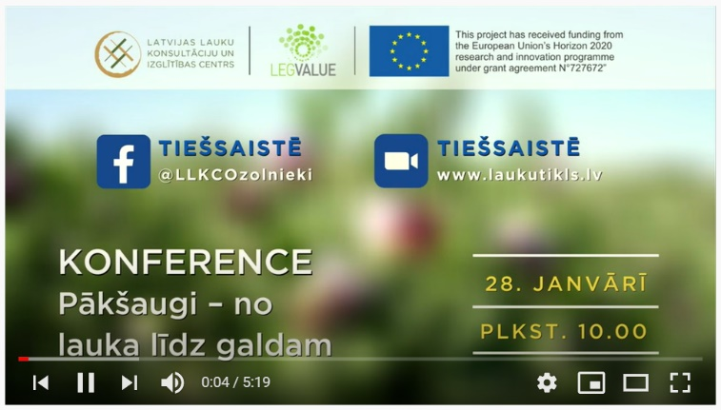
For more information contact Laura Kirsanova, (Augkopības konsultante, Augkopības nodaļa)
SIA "Latvijas Lauku konsultāciju un izglītības centrs" E-pasts: laura.kirsanova@llkc.lv
Weblapa: www.llkc.lv
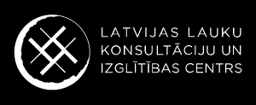

Presentations of the conference lecturers in Latvian language are available here. http://www.legvalue.eu/resource-section/
The recorded conference is available on the company's Youtube channel. https://www.youtube.com/watch?v=m96Ox_5O1dM&list=PLtf9tPuLditHo3OjY2S3byo4v05t73iIf

Legume field trials in Latvia:
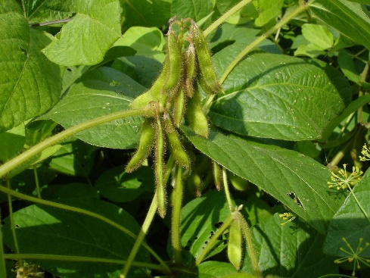
In the South Kurzeme region of Latvia, a test field was cultivated at a farm for two years to evaluate the opportunities for the cultivation of legumes – broad beans, peas and soybeans without the use of plant protection products, as well as the suitability of soybeans for Latvian agricultural and climatic conditions.

Main Conclusions:
- More attention must be paid to crop rotation and technical measures to prevent weed proliferation must be implemented to avoid disease and pests.
- Plant harrowing should be used to control weeds in sowings if no plant protection products are used.
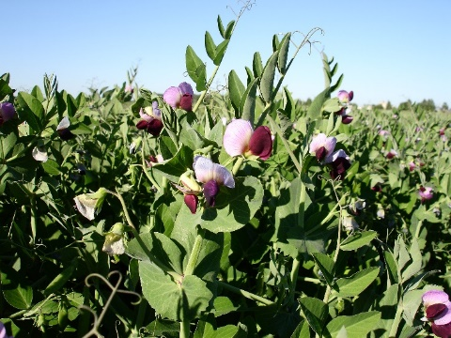
- As the farm does not plan to use plant protection products for environmentally friendly management, field beans will not be grown, as it was ensured that high-quality and high yields cannot be obtained without the use of plant protection products.
- The farm plans to continue growing peas and soybeans, assessing the experience gained and the suitability of soybeans for the region's climate.
More on field trials and the results you can find out ( In Latvian): http://new.llkc.lv/lv/nozares/augkopiba/paksaugu-audzesanas-izaicinajumi

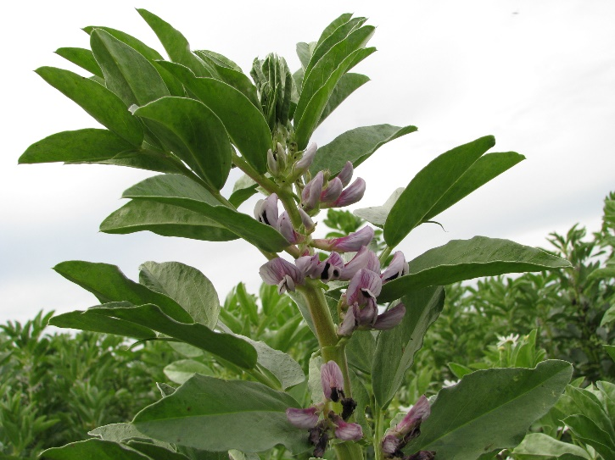
Legume-related projects in Latvia:

Institute of Plant Protection Research "Agrihorts" of Latvia University of Life Sciences and Technologies implements the project “Evaluation and identification of the most effective control methods for topical pests of legumes and identification of factors influencing the viability of pollinators important for agriculture”
The project carried out research in three different directions. Therefore, this project has three goals with the appropriate tasks to achieve them.
Aim one: Biology and ecology of broadbean seed beetle (Bruchus rufimans), as well as plant protection strategies.
Aim two: to study the factors influencing the viability of honeybee (Apis mellifera) flocks and to develop a methodology for assessing the risk posed by the use of plant protection products to honeybee flocks in Latvia.
Aim three: study the diversity of fauna and species of bee (Apodea) in the agrocenosis of Latvia.
More information about the project: http://agrihorts.llu.lv/en/node/460

Institute of Agricultural Resources and Economics (AREI) implements the project “Innovative Pesticide-Free Weed Control strategy in Cereal and Grain legume sowings”
Project duration: 2020 – 2023
The aim of this tresearch is to study the effectiveness of an innovative weed control method in Latvian conditions and to develop effective weed control technologies in cereals and legumes (peas / field beans). To find out the advantages and disadvantages of the new technology, to evaluate its economic and ecological aspects.
More information about the project: https://www.arei.lv/en/innovative-pesticide-free-weed-control-strategy-in-cereal-and-grain-legume-sowings

News from The Netherlands:

Wageningen….
Mid April 2021 Ruud Timmer has appeared in a television program and was asked about his opinion on growing legumes in The Netherlands. This followed an article in a newspaper on the impact of our large Dutch livestock production on the deforestation of the Amazon.
https://www.npostart.nl/atlas/21-04-2021/VPWON_1328183
The soya item start at 12 minutes and 30 seconds.

News from Germany:

Legume demonstration networks in Germany
As a part of the protein crop strategy the Federal Government originates demonstration networks on various legume species in Germany. The aim of these networks is to strengthen advisory services and knowledge transfer.

Soybean Network: Duration 09.2013 to 12.2018
https://www.lfl.bayern.de/schwerpunkte/eiweissstrategie/072188/index.php

Lupin network: Duration 2014 to 2019
http://lupinen-netzwerk.de/

Pea/bean demonstration network (Demonet Erbo): Duration 2016-2021
https://www.demoneterbo.agrarpraxisforschung.de/

Network for fine-seeded legumes (Demonet-KleeLuzplus): Duration 2019-2022
https://www.demonet-kleeluzplus.de/index.php

A new legume demonstration network that will deal with dry pea, faba bean, lupine and soy bean is planned to started in 2022 with a duration of six years. The focus here will be on conventional farming.

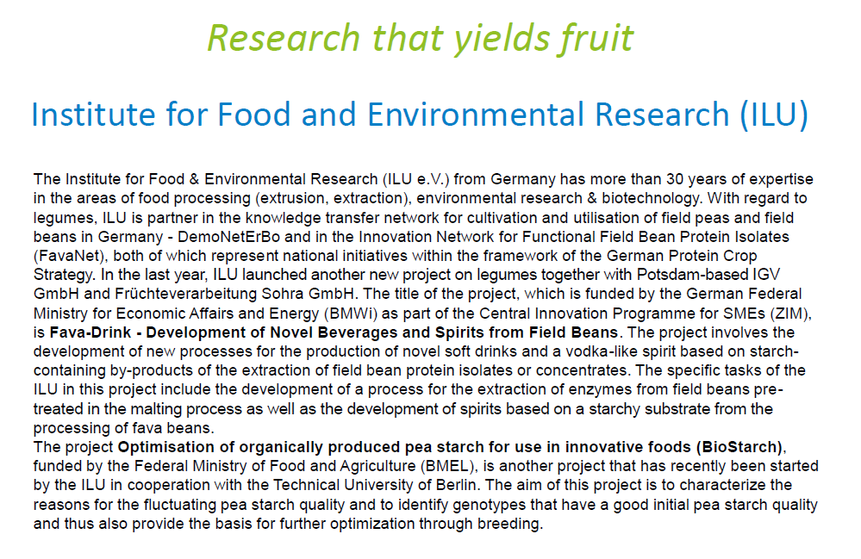

News from France:

French version of the CAP with positive impact on legumes
On May 21, Julien Denormandie (Minister of Agriculture) presented the main lines of the French version of the CAP, the National Strategic Plan (NSP), marked by a stability of resources dedicated to each of the major tools and, in terms of coupled aid, a doubling for plant protein at the expense of animal aid.
Out of the 15% envelope of the first pillar of the CAP dedicated to coupled aids, the Minister of Agriculture will progressively increase the budget allocated to plant protein, which will rise from the current 2% to 4% at the end of the next programming period. Direct aid for plant protein will increase from 2% to 3.5% at the end of the period, and an operational program dedicated to plant protein with 0.5% will be created as of 2023. This creation will be done at the expense of coupled animal aid for cattle, sheep and goats.
As expected, the amounts paid to farmers under the eco-regimes (new eco-conditionality of decoupled aids) will be of two levels ("standard" or "superior"), and according to three access paths: agronomic practices, certification and agro-ecological infrastructures. A subtlety has been added: agro-ecological infrastructures will make it possible to obtain a "bonus" in the other two paths. Organic farming and High Environmental Value (the third level of environmental certification) will give access to the "higher" level, and the Minister has undertaken to open work on access to eco-regimes through level "2+" environmental certification, without specifying for what level of remuneration.

In terms of agronomic practices, the principles adopted are no-tillage on a percentage of grasslands, plant cover on a percentage of inter-row areas and diversity of crop rotation on arable land (including leguminous plants, plant proteins, weeds, with special cases for farms with a high percentage of permanent grasslands or a small area of arable land).
Source : Mathieu ROBERT (AGRA PRESSE) May 21, 2021
Translated with www.DeepL.com/Translator (free version)

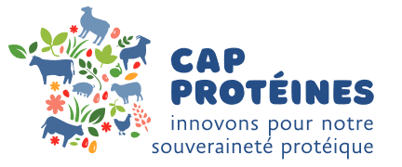
With the launch of France Relance (the French recovery plan) by the government in December 2020, an opportunity has arisen for the agricultural, plant and animal sectors to commit to an ambitious and unprecedented program to regain France's protein sovereignty. Protein sovereignty is a strategic issue that concerns, on the one hand, France's dependence on fluctuations in the world markets for protein-rich feedstuffs (especially soybean meals) and foods and, on the other hand, the environmental issues related to these crops (deforestation, carbon footprint, GMOs, etc.). The prospective work carried out by the national farming and industry sector for several years and the recently initiated recovery plan are now converging in the 2030 Protein Plan, whose objective is to ensure our protein sovereignty by 2030. This Protein Plan includes an important research, development, innovation and transfer component, entrusted to Terres Inovia and Institut de l'Élevage: the Cap Protéines program.

The challenges of protein sovereignty: reducing three vulnerabilities
In the context of climate change, which is forcing agriculture and livestock farming to rethink their practices, while accounting for new consumer demands in terms of the environment and product quality, protein sovereignty aims to:
1 - Cover the deficit in plant-based proteins intended for human consumption in order to respond to an increase in demand (rise in the world's population, flexitarian diets, expectations for local products, etc.).
2 - Reduce our dependence on imports of plant proteins for animal feed (especially monogastric species, i.e. poultry & swine), some of which are linked to deforestation, frequently from GMO crops and have an impact on the environment (transport, etc.). 3 - Strengthen the protein autonomy of ruminant farms (cattle, sheep and goats) by increasing their capacity to produce and use protein-rich fodder (legumes, protein plants, etc.).

The ambition of Cap Protéines: sovereignty and competitiveness
It is with these ambitions in mind that the "Cap Protéines innovating for our protein sovereignty" programme, implemented by Terres Inovia and the Institut du Élevage, has been launched for a period of two years.
Cap Protéines will contribute to the success of the Protein Plan 2030 by implementing a major partnership-based experimentation, reference production and technical communication system. This investment in innovation in protein rich field crops (oilseeds and grain legumes) and livestock management will make it possible to jointly ensure the protein sovereignty and competitiveness of individual farms and the French farming economy. The programme is committed to mobilising the 100,000 oil and protein producers and more than 100,000 ruminant breeders in France.
Achieving this ambition requires major changes in production models on farms, which implies:
- Successfully diversifying crop rotation through innovation (new varieties richer in protein), the introduction of legume crops (genetic resources, agronomic references, etc.), and the preservation of oilseed production.
- Innovate in the diversification of protein-rich fodder production for livestock herds
- Develop production practices: agronomic expertise, management at the crop system level.
- Invest in research into new animal production models: animal genetics, rationing, optimising the use of fodder resources, etc.
- Innovate in the diversification of protein-rich fodder production for ruminant herds.
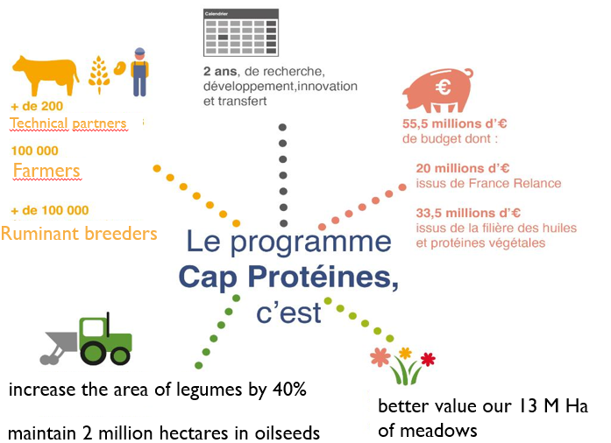

Five research, development, innovation and transfer projects to promote protein sovereignty

1 Evaluate and disseminate new high-protein oilseed and resilient legume varieties
Today, oilseed and legume crops are not competitive with the dominant crops in French crop rotation (cereals and maize). As essential components of protein sovereignty, these species must see their genetic potential increase, with a wider range of available varieties and an adaptation to the specificities of target environments and to the challenges that are specific to them (climate change, pest pressure, etc.).
Currently, three obstacles must be overcome to increase the use of new varieties and to respond to the challenges of the Protein Plan:
- The almost total lack of genetic progress in pulses for human consumption (lentils, chickpeas) on the French market.
- The low investment of private research on grain legumes due to the autogamous reproductive regime of most legumes, which leads to a high rate of recourse to farm-saved seeds rather than certified seeds.
- The advent of new criteria that are still not well known for oilseeds: pest resistances and protein rates for rapeseed and sunflower, adaptability to new production regions for sunflower, etc.
The objective is to accelerate the development of varieties of pulses adapted to French soil and climate conditions (a cooperation scheme with Mediterranean ambitions will be set up during the two years).., to increase the share of recent varieties of grain legumes used in crop rotation for pulses and to optimise the choice of varieties for oilseeds, in order to meet market demands in terms of protein content or adaptation to difficult production contexts.

This project is conducted by Terres Inovia in collaboration with the regional and departmental chambers of agriculture, cooperatives, traders, seed companies, the UFS, Anamso and Icarda.

2 Increasing the competitiveness and sustainability of protein rich field crops (oilseeds and grain legumes) production
Producing local plant proteins adapted to market expectations requires the production of new references to provide farmers with the necessary means to improve crop management.
To increase the competitiveness and sustainability of protein crops production, this project will:
- Identify and alleviate the obstacles to the cultivation of grain legumes, by disseminating technical recommendations for the integrated protection of legumes and soybeans.
- Design technical itineraries adapted to meet the demands of growing "HighPro" markets in terms of quality and volume for rapeseed and sunflower in the regions concerned
- Develop expertise and transfer knowledge to facilitate protein rich crops in organic farming
- Enrich the range of digital tools for managing protein-rich crops (rapeseed, sunflower, peas, soybeans) to enable demonstrations throughout the country.
- Accelerate the emergence and dissemination of knowledge on innovations in cropping systems in order to deploy innovative rotations throughout the country and increase the references acquired while supporting their appropriation by farmers. 200 local meetings per year and some twenty platforms will be set up, supported by the publication of videos, webinars, podcasts, etc.
Terres Inovia is mobilising many partners, including producers, regional and departmental chambers of agriculture, APCA, cooperatives, traders, FNAMS, digital service companies, Arvalis - Institut du végétal, ITB, …

3 Integrating locally produced, sustainable and diversified protein rich crops into value chains to promote more durable food systems
4 objectives are addressed in this project to enable the improvement of non-price competitiveness factors of protein rich raw materials:
- The wide deployment of analytical tools and dissemination of information on the qualities of national production, to enable operators to source seeds and oil cakes reliably to meet the needs of their market segments (creation of 4 new quality brochures for protein crops and pulses, development of crop quality prediction models, etc.).
- The rapid and sustainable transfer of better combinations of oilseed processing techniques to increase the nutritional efficiency of oilcake and other protein-rich materials (PRM), in order to reach zootechnical performances equivalent to imported soybean meals.
- Supporting innovations that increase the use of national plant proteins in agri-food processes, demonstrate their nutritional value, and better understand consumer expectations of plant proteins (health nutrition, local sourcing, etc.).
- The creation of an ecosystem to support innovation and the emergence of innovative companies throughout the value chain thanks to tailor-made support from ideation to acceleration (organisation of an annual innovation challenge on plant proteins aimed at students and researchers, organisation of two Hackathons per year to respond to industrial issues around plant proteins).
The project involves Terres Inovia's seed processing R&D unit based in Pessac (33) and its physico-chemical analysis laboratory based in Ardon (45). The work is carried out in close collaboration with Terres Univia, Iterg, Arvalis - Institut du végétal, Ifip and Itavi

4 Developing the protein autonomy of ruminant farms
The primary source of protein for livestock farming is 13 million hectares of grassland. However, the protein autonomy of ruminant farms is not complete: it varies from 47% for goats to 86% for beef cattle or sheep, while dairy cattle farms are at 62%. In France today, 44% of soybean meal is consumed by ruminants (mainly dairy cows).
The livestock component of the Cap Protéines programme is structured around two main objectives:
- To increase protein production in livestock through legume-based grasslands and cereal-protein mixtures.
- To enhance the value of oilseed cakes and seeds produced in France and Europe for livestock farming.
4 actions will be implemented over a two-year period:
- Precision and dissemination of agronomic levers to produce more proteins in livestock and to specify their zootechnical interests (40 demonstration platforms, 40 trials on animal feed in experimental farms);
- The implementation and demonstration of high protein autonomy breeding systems throughout mainland France and on Reunion Island (11 prototype systems, 330 pilot farms, including 13 in the overseas departments, analyses and simulations on databases, etc.);
- Equipping farmers with 10 tools for evaluation, advice and decision support for the diagnosis and optimisation of their protein production.
- The deployment of a coherent and concerted transfer and communication throughout the territory. A massive production of references from other actions will only be useful if it is made available to farmers, taking into account their expectations, needs, difficulties and specific situations. The objective? To facilitate the redesign of their farming system.
The project mobilises all of the Institut de l'Elevage's partnership mechanisms. In particular, the F@rmXP network of experimental farms and the INOSYS Réseaux d'Elevage system. Arvalis - Institut du végétal, ITAB, Chambers of Agriculture, Livestock Advisory Companies, CIVAMs, BTPL and agricultural colleges are closely involved in the project.

5 Sharing information from producer to consumer
4 levers will make it possible to produce information useful to operators for their decision-making, to enhance the value of their products for consumers and to design innovative tools that will make it possible to share information widely within all sectors:
- Encouraging the production of protein-rich plants and their processing in France by producing and disseminating original technical and economic information that is not yet available (sector diagnosis, price construction, cost analysis, logistics efficiency, etc.).
- Evaluation of the feasibility of increasing the supply of local proteins, particularly for human consumption and in the island situation of Reunion.
- Designing and disseminating a tool (mobile application) to all animal and plant sectors to provide and simulate information on fluxes throughout the value chains (supply and demand of plant proteins for animal and human consumption) and their impact on national sovereignty.
- Designing the optimal conditions for collecting and tracing data that will enhance the value of the sustainable French legume sectors through the pilot case of soya, from production to consumer purchase.
- Designing an observatory on the use and consumption of plant proteins. This observatory will be built from purchase data, seed use data and consumption data.
The project is coordinated and communicated by Terres Inovia in partnership with Terres Univia and a joint platform of the plant and animal farm and industry boards, Armeflhor, Idele, Arvalis - Institut du végétal, Acta and APCA.

In summary:
The human involvement and financial investment supported by the Cap Protéines programme will make it possible to acquire and disseminate new references through joint work with 200 technical partners and development organisations. The aim is to enable crop growers, and animal breeders to adopt new approaches and techniques. The next decade must see practices evolve so that breeders and their sectors consider alternatives to protein imports and so that national plant sectors meet animal and human food needs. Because protein sovereignty will not be achieved without farmers, livestock breeders and stakeholders in the field, a socio-economic approach will make it possible to understand any obstacles in order to support change. The dissemination of the results of the 5 projects will be based on the organisation of demonstration days (open days, etc.), the provision of technical references (guides, fact sheets, videos, etc.) and digital tools and applications.

Over 800 field trials on oilseeds and protein crops
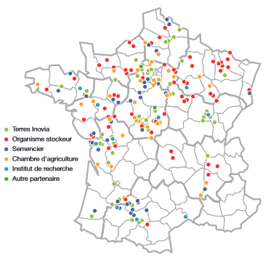

A new partnership with agricultural chambers: Terres Inovia and agricultural chambers will set up crop observatories of tens of farmer’s fields for multiple crops in 8 regions, to acquire references on the limiting and success factors of these crops. Moreover, in 6 flagship territories, farmer groups involved in agroecological transitions and crop diversification strategies will be set up to consolidate their approaches and be able to further disseminate them.
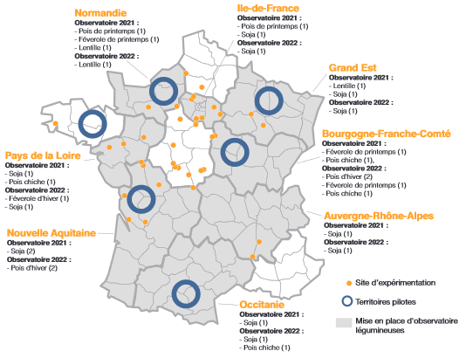

330 pilot livestock farms
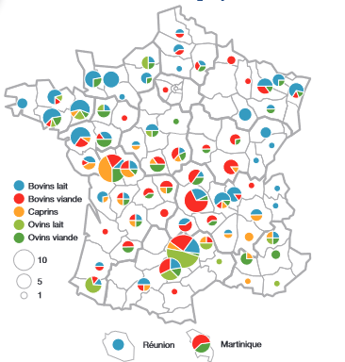
These 330 livestock farms, including 13 in overseas territories, are located in 75 departments with local advisory organisation and serve to conceive and disseminate new results and trajectories of change for livestock systems.

19 farms in agricultural secondary schools to train future livestock breeders
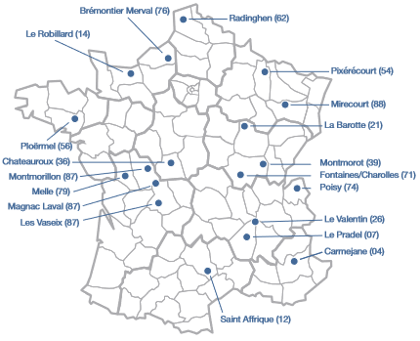

19 sites for livestock and forage experiments
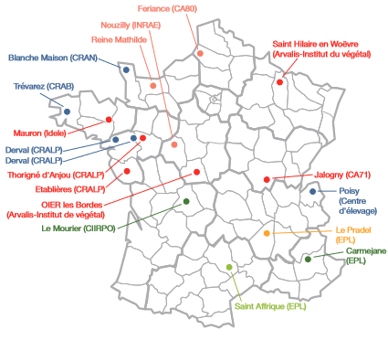
www.terresinovia.f www.idele.fr

News from the UK:

The UK government is taking support for agriculture in a different direction. The recently passed Agriculture Bill will set a new era for the UK industry outside the CAP. The BPS system of farm subsidy is to be replaced and details of the planned Environmental Land Management Scheme (ELMS) are keenly awaited. The emphasis will be upon payment to growers for public good, with a focus on sustainability and the environment in land management practices.

Progress in the development of this ELM scheme and a current over view can be followed here:
https://www.gov.uk/government/publications/environmental-land-management-schemes-overview/environmental-land-management-scheme-overview

There are 3 new schemes that will reward environmental land management:
- Sustainable Farming Incentive
- Local Nature Recovery
- Landscape Recovery
These schemes are intended to support the rural economy while achieving the goals of the 25 Year Environment Plan and a commitment to net zero emissions by 2050.

In 2022 the UK will start piloting the Sustainable Farming Incentive scheme. This is part of the government’s plans for how to reward future sustainable farming practices, now the UK has left the EU Common Agricultural Policy.
https://www.gov.uk/government/publications/sustainable-farming-incentive-scheme-pilot-launch-overview

It is not clear at the time of publication what crops or whether any crops, will be specifically mentioned within the scheme. It is therefore unclear if these imminent policy changes will have any significant impact on pulse crop production in the UK. It is expected that there will be further announcements from the government in June.

News from Denmark:

Trials with grain legumes for food in Denmark :

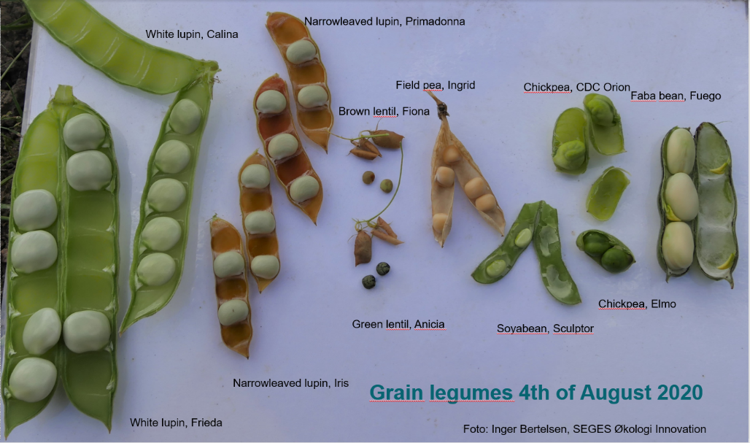
Based on an increasing interest for plant-based food in Denmark SEGES decided to test a wide range of grain legumes in organic trials in 2020 as part of the LegValue project. Species normally grown in Denmark are faba bean, field pea and narrow- leaved lupin. New species in the trial were white lupin, lentils, chickpea and soyabean. The trials were done in two location Mideast Jutland and Bornholm. The growing season on Bornholm was very dry and the trial suffered from draught, so the yields were limited, but the harvest was not so late. In Mideast Jutland the growing season was perfect with sufficient rainfall, this

led to high yields in all species. In lentils, chickpea and soyabean the yield was higher than expected. At this location there were still plenty of water available in the soil in autumn, which meant that harvest was late especially in soyabean (6th of November) and white lupin and chickpea (29th of September). Due to an autumn with good harvest day scattered over a long period, we succeeded in harvesting all crops. The trials highlight the challenge of the short growing season and the unstable (often rainy) condition in harvest that the farmer must be very much aware of choosing a late crop. For growing the latest of the grain legumes, we need to work on harvest techniques e.g. swathing or harvest of green seeds to make sure to get a good quality.

News from Switzerland :
Nathaniel Schmid, Lausanne, FiBL

Activity 1 – Workshop scenarios of legumes development

In the framework of our projects to support the construction and consolidation of the LegValue legume value chains, FiBL invited all the actors of the soybean value chain to a virtual workshop (ZOOM). The need to maintain the excellent dynamics created more than 5 years ago and the need to answer some questions about the future of our arable land use seemed to us obvious reasons to do everything possible to bring these actors together.

The goal was to answer a question about the development of open land use in Switzerland and for that we will first put ourselves in extreme socio-economic situations, to then determine a vision that seems to us to be the most probable in the next 15 years. This exercise allowed us to visualize the evolution of the surfaces of the different crops present in our rotations.

In the second part, on the basis of the priority areas of work established during the workshops carried out in the last phase of the B3S project, the actors expressed their situation and their needs, take note of the expectations of the workshop participants and take the opportunity to jointly set new objectives with full knowledge of the facts.

Finally, the actors were asked to define within the group, the new directions to be given, the needs in terms of collaboration, projects and economic and personal means necessary to continue to consolidate the legume chains from selection to sale.

Activity 2 – Major Publication on OCL platform (Oilseeds and fatcrops and lipids)
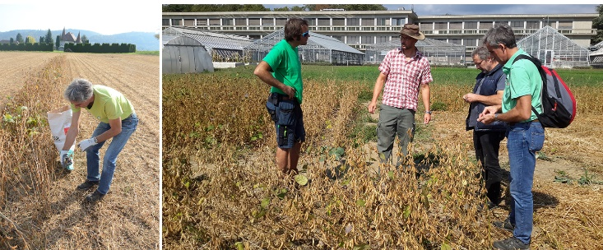
A farmer in northwestern Switzerland (Aargau) selecting individual soybean plants within the heterogeneous CCP population on his organic farm (left). Farmers receiving initial training in selection of soybeans from breeder Claude-Alain Bétrix at Agroscope Changins in Nyon.

Organic Soybean cultivation experiences an upscale at the moment in Switzerland. As in the rest of Europe, Switzerland is still heavily dependent on protein imports. After years of stakeholders efforts of the development of a value chain for organic soybeans for human nutrition, various attempts to develop the soybean cultivation for feed proved to be fruitful despite the fact that Swiss price level is beyond competition for world market prices. The organic farmers themselves decided to become, at least partially, more independent from overseas soybean imports by opting for organic soybeans of European origin since 2019. Furthermore, Bio Suisse decided that from 2022 on, all ruminants under Bio Suisse certification must be fed with feed of Swiss origin, concentrates are limited to 5% of the ration. Since many years numerous projects are carried out to increase the domestic protein production by developing suitable production systems for peas, faba beans, lupines and soybeans with stakholders along the value chain. Since more than 30 years, Swiss breeders successfully develop 00 to 000 soybean varieties with a focus on human nutrition, organic soybean cultivation and the respective value chains from breeding to endproduct is developing strongly. This article will shed light on particular aspects and drivers, specific measures, relevant projects and cultivation techniques of organic soybean production in Switzerland in the past years and will give an outlook on the future of organic soybeans.

Link for the whole publication:
https://www.ocl-journal.org/articles/ocl/full_html/2020/01/ocl200059s/ocl200059s.html

Activity 3 – Regional organic soybean value chain takes place in Geneva

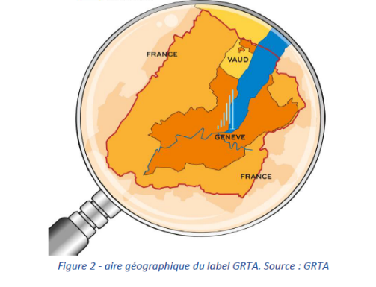

Geneva's soyfood sector is promoted through the GRTA brand, which identifies products from the region's agriculture. It is primarily oriented towards a local market, which already exists and which should grow in the coming years. Thus, all of the food soy produced in the canton of Geneva is both organic and GRTA certified.
We will see that the demand for organic soybeans for animal feed should also increase in the coming years following the evolution of the Bio Suisse specifications in this area.
The structuring of the Geneva food soy chain is therefore a twofold challenge: to meet the local demand for food soy while at the same time valorizing the declassified soybeans on the organic animal feed market at the national level.

GRTA is a guarantee mark created in 2004 by the State of Geneva, which owns it. It has approximately 360 users (producers, processors, distributors, etc.) spread over the canton of Geneva, the free zone and a small area of the canton of Vaud (between Geneva and Céligny).
GRTA makes it possible to identify and ensure the traceability of products from Geneva agriculture.

Source: Céline Abadia, 2020, Etude préliminaire pour la création d’une filière soja conforme aux exigences de la marque de garantie Genève Région – Terre Avenir (GRTA) et du cahier des charges de BioSuisse.
Link to GRTA brand : https://geneveterroir.ch/

Activity 4 – Legume Co-creation workshop surveys consumers and famers

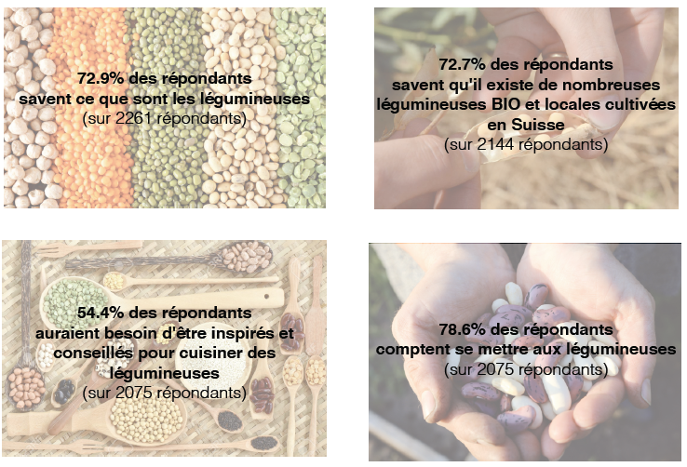
Nathaniel Schmid, Lausanne, FiBL

Since April 2021, a co-creation workshop based on the design-thinking method, mandated by Bio-Fribourg and organized by the above-mentioned institutions, is being carried out. The observation shows a consumer craze for pulses as an alternative to animal proteins, but the local supply chains are struggling to provide the raw materials.

The workshop consists in defining the level of knowledge of consumers and actors of the mainly cereal and oilseed oriented sectors on pulses, their benefits for health and the environment through interviews, analyzing the answers, defining actions according to the target audience and presenting a scheme of activities necessary to consolidate the implementation of production, processing, logistics, marketing communication and sales of products based on local organic pulses in the region of Fribourg and surroundings.

This work must be presented to the mandators for implementation in the coming years.

Activity 5 – Annual crop workshop focused on legumes in 2021

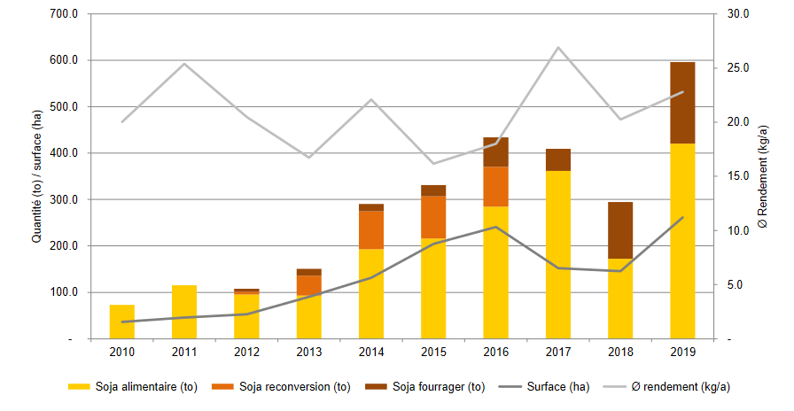
Source: Mühle Rytz, Biberen, February 2021

The Organic Field Crops 2021 workshop, held online on February 18 and organized by FiBL Lausanne, provided an overview of soybean and other legume crops.

Claude-Alain Bétrix (Agroscope) first presented the approach to create varieties adapted to Swiss climatic conditions with a program oriented towards food quality. The participants were then able to see the results of three strip trials comparing four varieties registered on the variety list. The Austrian variety Aurelina was the most productive but can be problematic in terms of ripening at high altitudes.

These trials highlighted the importance of choosing the variety best suited to the location. In addition to variety selection, Jürgen Recknagel (LTZ Augustenberg) described the key points for successful soybean cultivation: seed inoculation, soil preparation, weed control and harvest care are some examples. For regions that are not favorable to soybean cultivation, lupins represent an interesting alternative, whether it is blue lupins in associated cultivation or white lupins in pure cultivation, taking care to choose the new anthracnose tolerant varieties.

The workshop also provided an update on the market with strong demand for soybeans and lupins. Biofarm also indicated that rapeseed, sunflower, flax and lentils were in demand.

All the presentations are available on this link: https://www.bioactualites.ch/actualites/nouvelle/beau-succes-pour-le-cours-grandes-cultures-2021.html

Activity 6 – Increase in reference prices for pulses

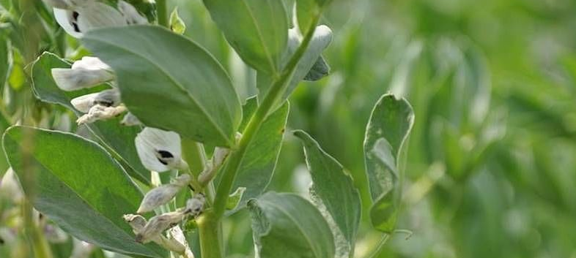
For soybeans, lupins, protein peas and field beans, the changes in the reference prices and the incentive contributions result in an increase of two francs per deciton for producers. picture: FiBL, Thomas Alföldi

At the Round Table on May 19, 2021, representatives of producers, feed manufacturers and importers agreed on changes to the reference prices for Bio Suisse feed grain.

The reference prices remain the same for barley, oats, triticale, feed rye, feed wheat and grain corn. For soybeans, lupins, protein peas and field beans, the changes in reference prices and incentive contributions result in an increase of two francs per deciton for producers for all pulses. Within the framework of the Reference Price Round Table, producers and processors have agreed on an increase in the prices paid to producers for Bio Suisse pulses.

Market situation for organic feed grains and animal products
As in recent years, the domestic supply of organic feed grain continued to increase in 2020 due to the arrival of new farms and thus additional cultivated areas. 35,102 tons of organic feed grain from the 2020 harvest could be taken up.

This represents an increase of 3%. The proportion of indigenous feed grain is now 80.65%. The feed requirement increased by 2.5 % in the same period.

Source and Link to Bio Suisse communiqué: https://www.bioactualites.ch/fileadmin/documents/bafr/marche/grandes_cultures/Cereales_fourrageres/210520_cp_bs_prix_de_reference_cereales_fourrageres.pdf

Link to Bio Suisse recommendations to farmers:
https://www.bioactualites.ch/fileadmin/documents/bafr/marche/grandes_cultures/Marktuebersicht_2021_05_FR.pdf

Activity 7 – From organic and regional soybean to gourmet products

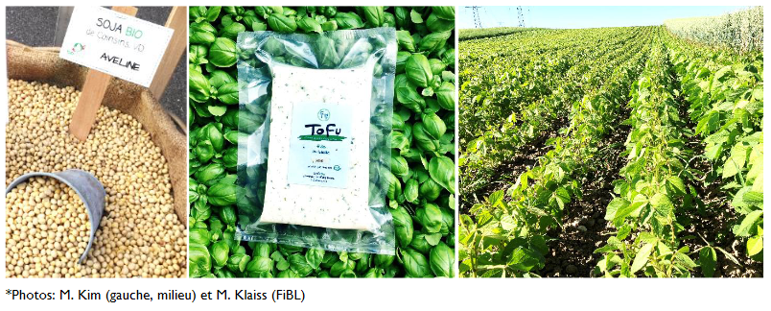
On Friday, the 21st of August 2020, the interested people were invited to the TerraSoja farm of Mrs. Min Jung Kim: her team refines soybeans, mainly from the Jaggi organic farm. Francis Jaggi has been growing soybeans for a long time and, in collaboration with FiBL and Agroscope, he selects his own farmer's variety.

The herbs used for the production of tofu also grow on the Jaggi family's farm. It couldn't be more regional. This special network opened its doors to everybody: the workshop offered presentations as well as a visit to Mrs. Kim's farm and tofu workshop. People learned about the cultivation of organic soybeans, varieties, food grade soybeans and traditional processing, and received suggestions for successful implementation of the organic and Bio Suisse requirements for tofu production.

The workshop was aimed at professionals working in farms, processing, kitchens and stores, trade, schools and counselling.

Link to the food transformation workshops: https://www.bioactualites.ch/fileadmin/documents/ba/Agenda/Agenda_2021/Kurskalender-Verarbeitung-FiBL-2021.pdf
……………………………………………………………………………………………………………………………………………….

CROP DIVERSIFICATION CLUSTER

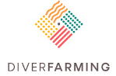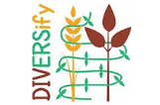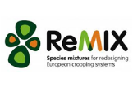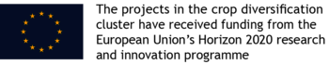

The crop diversification cluster brings together research projects which operate in countries across Europe to increase the impact of crop diversification research. The cluster encourages sustained uptake of diversification measures by European farmers and through innovations across the agri-value chain.

The projects in the cluster - Diverfarming, DiverIMPACTS, DIVERSify, LegValue. ReMIX and TRUE - received funding from the EU Horizon 2020 research and innovation programme.
https://www.cropdiversification.eu/

Latest News:

Diver Impacts Project: https://www.diverimpacts.net/
The project continues until May 2022.
Cluster study group 4 focusses on diversification through intercropping, with a special focus on grain legumes, and diversification of vegetable cropping systems. https://www.diverimpacts.net/case-studies/cluster-description.html

Diverfarming project: http://www.diverfarming.eu/index.php/en/
Crop diversification and low-input farming cross Europe: from practitioners' engagement and ecosystems services to increased revenues and value chain organisation. This project continues for 2 more years.

REMIX project : Redesigning European cropping systems based on species MIXtures
https://www.remix-intercrops.eu/
On 23rd March 2021 the final ReMIX-DIVERSify Conference gathered 300 participants to discuss "Intercropping to boost agroecology in European Agriculture".

Presentations, reports and policy recommendations can be found here. https://www.remix-intercrops.eu/News2/ReMIX-DIVERSify-Final-Conference

Diversify project: https://www.plant-teams.eu/

The DIVERSify project worked to understand how to optimise the performance of crop species mixtures or ‘plant teams’ to improve yield stability, reduce losses to weeds, pests and diseases, and enhance resilience to environmental change. Working together, a team of international researchers, farmers and other stakeholders, developed evidence and guidance on how to improve the productivity and sustainability of European agriculture through the application of ecological concepts.
Intercropping information , crop mixture guides and policy tools can be found here. http://plant-teams.org/#guidestoolboxes

The project concluded in March 2021. Information remains available online through it’s various social media outputs. [ Twitter @PlantTeams , Facebook https://www.facebook.com/PlantTeams/ ,
Flickr https://www.flickr.com/photos/diversify ,
Instagram https://www.instagram.com/diversifyplantteams/ and through Research Gate https://www.researchgate.net/project/DIVERSify-Designing-Innovative-Plant-Teams-for-Ecosystem-Resilience-and-Agricultural-Sustainability ).

True project: www.true-project.eu

The 6th News letter of the True Project was published in March 2021
Extended until September 2021. The project is targeting the identification of transition paths for more legumes on Europe’s fields and plates. Their latest newsletter highlights and links to many new papers and deliverables published to which you can find links on their blogposts ( https://www.true-project.eu/blog-notes-from-the-field/) and other news on the TRUE website. For information about the structure of TRUE please visit www.true-project.eu

The News letter can be downloaded here. https://www.true-project.eu/publications-resources/newsletter/

The TRUE project has partnered with LegValue the launching of the Legume Innovation Network ( LIN)
www.legumeinnovationnetwork.eu Linked In https://www.linkedin.com/groups/8955372/

……………………………………………………………………………………………………………………………………………….

FINAL CONFERENCE

“European Legumes in Transition”

Overtaken by the Covid ’19 pandemic the final conference of the Legvalue project was cancelled. Instead, a series of 8 webinars was launched in conjunction with the TRUE project.

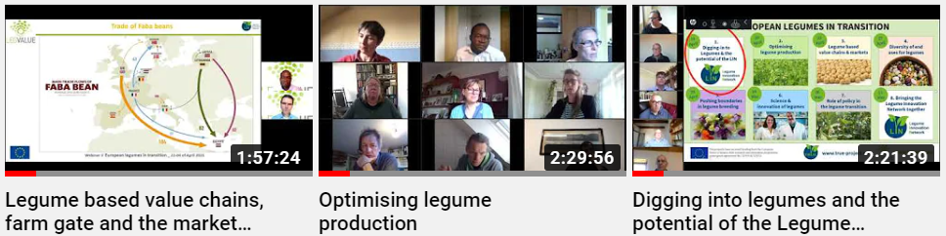

Leading influencers delivered messages about how they believe legumes can be exploited to deliver a more sustainable and environmentally resilient agricultural system for Europe, and the opportunities that exist to realise the transitions envisaged.

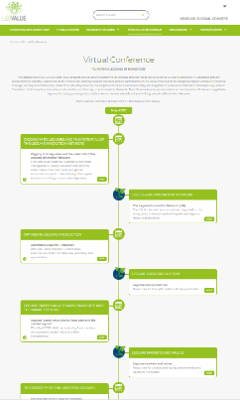
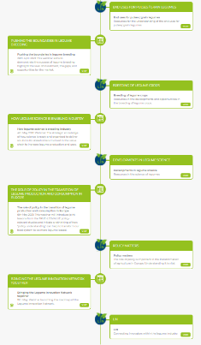
A virtual conference platform was established upon which the webinars and associated reading rooms were hosted and where the associated papers and recordings of the events can be found. http://www.legvalue.eu/virtual-conference/

The events were held between 14th – April to 11th May 2021

Provides details of the presentations within each webinar in the final event report.

- Introduction: Digging into legumes and the potential of the LIN
http://www.legvalue.eu/virtual-conference/digging-in-to-legumes-and-the-potential-of-the-legume-innovation-network/
This webinar introduced the series. Illustrating how crop management, variety development and the wider value-chain elements and global economics impact on the delivery of ecosystem services, including the success of growers. It outlines how the value chain functions from processing through to marketing. End-user concerns are highlighted from the perspective of feed and food, health, and environmental functions. It outlines how the subsequent webinars will address these issues.
- Optimising legume production
http://www.legvalue.eu/virtual-conference/optimising-legume-production/

A farm level examination of farmer attitudes, activities, and approaches.
Using studies of success stories to illustrate opportunities in crop management and variety availability to demonstrate ecosystem service benefits, environmental impact and the contribution to health, nutrition, and the economy. Demonstrating how through innovation a network exists that holds the world of legumes together.

- Legume based value chains and the market beyond the farm gate
http://www.legvalue.eu/virtual-conference/legume-based-value-chains-farm-gate-and-the-market-beyond/
Exploring how markets are organised, added value and their transparency. Illustrating how success stories function in the value chain through processing to the commodity market. Demonstrating how networks exist linking farmers to the markets, and how they can be strengthened through innovation. Leading to an introduction to the end-uses for legumes, the theme of the next webinar.
- The diversity of legume end uses
http://www.legvalue.eu/virtual-conference/the-diversity-of-end-uses-for-legumes/

Increased awareness of the need to transition to sustainable food systems is revitalizing legume consumption in Europe, leading to a compilation of innovations and initiatives that aim to put legumes as a foundation for this transition. This webinar summarized initiatives that aim to enable the comeback of legumes and their placement in a diversity of end uses, enabling them to become more prominent in human diets and animal feeds.

- Pushing the boundaries in legume breeding
http://www.legvalue.eu/virtual-conference/pushing-the-boundaries-in-legume-breeding/
The goals and objectives in legume breeding, the gaps, the gap opportunities and management of expectations. Demonstrating the success of legume breeding. Highlighting the level of investment, the gaps, and opportunities for the market. Exploring the barriers to greater success and indicating where innovation can and is being successful in influencing feed and food value for the benefit of health, nutrition, and the environment. Introducing how breeding links with science and asking the question how can the whole value chain support research rather than just the farmer?
- How science is enabling industry
http://www.legvalue.eu/virtual-conference/how-legume-science-is-enabling-industry/
The strategic knowledge of how science is ready and organised to deliver solutions for stakeholders involved in the value chain to increase legume production and uses. Exploring the success of science in delivering knowledge and how the science is integral to the network standing ready to facilitate innovation in the value chain. How the science community is ready to engage with industry to create a function network for information exchange.
- The role of policy in the transition of legume production and consumption in Europe
http://www.legvalue.eu/virtual-conference/the-role-of-policy-in-the-transition-of-legume-production-and-consumption-in-europe/
This webinar introduced joint lessons from the TRUE-LEGVALUE policy-relevant studies to initiate a rethinking of how "policy understanding" can help to transform our food system to be more legume-based. The potential impact and contribution of policy instruments in scenario-based transition pathways towards greater legume production and consumption will be discussed.
- Bringing the legume innovation network together
http://www.legvalue.eu/virtual-conference/bringing-the-legume-innovation-network-together/
A synthesis of the key messages from growers and markets and end-users throughout the supply and value chain with a summary for policy makers. The webinar also sought to establish the foundation from which a roadmap for the Legume Innovation Network may be established conjunction with a dedicated website - www.legumeinnovationnetwork.eu
Over 1,250 registered to attend the webinars and at the time of publishing over 1400 has attended live or viewed the recorded content.

The recorded and indexed events can also be found directly on the Legume Innovation Network you tube channel https://www.youtube.com/channel/UCENPp8XqD7qYc_YG7V3n5cQ

The individual presentations used in each webinar are made available as additional resources and can be accessed by the relevant webinar links above.

……………………………………………………………………………………………………………………………………………….

LEGUME INNOVATION NETWORK

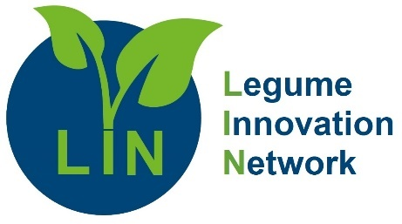
A legacy of the TRUE and Legvalue projects as they approach their conclusions the European Legume Innovation Network is intended to maintain and grow a connected web, linking people with similar interests enabling challenges to be resolved more-easily, with potential partners finding resources for mutual benefit, helping one another in an industry that is currently at a low level.

The LIN was softly launched during the Webinar Series “ European Legumes in Transition”

This has huge potential, the benefits of legumes being increasingly realised by the wider world. It can be a stakeholders’ forum to promote awareness of new insights, services or requirements for commercially competitive production and consumption of legume crops in Europe - and directly help realise more sustainable agri-food systems.

The LIN is not exclusive -partners in all forms will be welcomed by their common interest – to help realise sustainable legume-supported agri-food systems. Registration to the LIN as an expression of interest can be made by registering companies on the Digital Innovation Hub, DIH-Agrifood within which the Legume Innovation Hub is already notionally established.
Register organisations as stakeholders via this link http://www.legvalue.eu/stakeholder-directory/

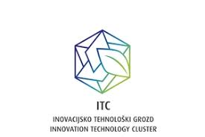
The LIN is also included as a network in the Digital Innovation Hub, DIH-Agrifood. Here organisations can list their specific areas of activity and connect with others of similar interests across different sectors and farming communities. https://mapping.dih-agrifood.com/

The LIN is also present as a group on LinkedIn where individuals can also contribute to networked discussions and information exchange on legume innovation topics of any kind. https://www.linkedin.com/groups/8955372/

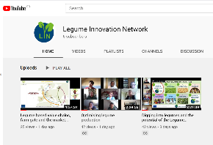
The LIN platform has its own YouTube channel where videos will be posted. The first postings are the recorded webinar series “ European Legumes in Transition” that launched the network https://www.youtube.com/channel/UCENPp8XqD7qYc_YG7V3n5cQ

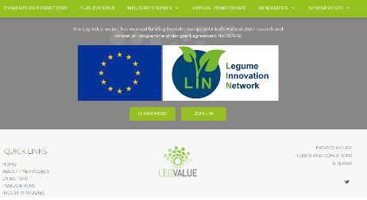
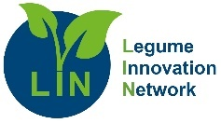
As the Legvalue project comes to a conclusion the project website will be re-branded for the LIN.
www.legumeinnovationnetwork.eu

The LIN has initially been started by those who formed the concept, but now needs those who value the concept to step forwards and determine its future.

The LIN should retain an enduring focus on innovation and issues spanning the legume supply networks and should be guided, by a founding constitution that ensures a wide membership base that embraces all aspects of:
- input and production, commodity processing and food technologies;
- trading markets, retailing plus new and emerging markets:
- cultural aspect including ‘sustainable consumption and environmental impacts;
- socio-economics, governance and policy-development.

Now is the time to get involved.
Become a founding member and be part of establishing an exciting network focussing on linking science and industry in an environment of innovation.
The LIN will develop under the direction of those that want it not under those that have launched the concept. If you see value in this concept and would like to ensure it succeeds then now is the time to put engage your enthusiasm.
Message and join via the website http://www.legvalue.eu/contact/

……………………………………………………………………………………………………………………………………………….

. EIP PRACTICE ABSTRACTS

The European Innovation Partnership (EIP-AGRI) prescribes a common format for interactive innovation projects.
https://ec.europa.eu/eip/agriculture/sites/agri-eip/files/eip_common_format_-_14_oct_2015.pdf
“The interactive innovation approach under the European Innovation Partnership Agricultural Productivity and Sustainability (EIP-AGRI)1 fosters the development of demand-driven innovation, turning creative new ideas into practical applications thanks to interactions between partners, the sharing of knowledge and effective intermediation and dissemination.”

The narrative describes Practice “Abstracts” and prescribes how a Short Summary for Practitioners on the (final or expected) outcomes (1000-1500 characters, word count – no spaces) “…….should at least contain the following information: − Main results/outcomes of the activity (expected or final) − The main practical recommendation(s): what would be the main added value/benefit/opportunities to the end-user if the generated knowledge is implemented? How can the practitioner make use of the results? “

'Practice abstracts': to facilitate contact and share information in the EU agricultural knowledge and innovation systems. Those produced by the LegValue project are hosted here: https://ec.europa.eu/eip/agriculture/en/find-connect/projects/fostering-sustainable-legume-based-farming-systems

They are also presented as “ Resources” on the LegValue website. http://www.legvalue.eu/resource-section/

- PA01 - Faba-bean & grass-clover cultivation and utilization in Denmark within dairy
cow farms – RUC
- PA02 - Perennial grasses (grass-clover) as feedstock for biogas production and supply
of organic digestate as fertilizer in Denmark – RUC
- PA03 - Faba-bean cultivation and utilization in Denmark within pig farms -RUC
- PA04 - Faba-bean & grass-clover cultivation on arable farms in Denmark – RUC
- PA05 - Price information/market price reporting for field peas in Germany - FSW
- PA06 - Bruchid beetle in faba beans - FSW
- PA07 - Integration of legumes into crop rotation – FSW
- PA08 - Current dominant crop sequences across EU: a typology based on LUCAS
dataset – INRA
- PA09 - Agronomic Scenarios of Reintroduction of Legumes into a French Territory –
INRA
- PA10 - How to grow Legume based Intercrops - INRA
- PA11 - Developments that can influence European supply chains. Project deliverable
5.1. A summary of Chapter contents - WUR
- PA12 - Developments that can influence European supply chains. Project deliverable
5.1. A summary of Chapter 2: The protein Challenge – WUR
- PA13 - Developments that can influence European supply chains. Project deliverable
5.1. A summary of Chapter 3: Environmental Services - WUR
- PA14 - Developments that can influence European supply chains. Project deliverable
5.1. A summary of Chapter 4: Feed - WUR
- PA15 - Developments that can influence European supply chains. Project deliverable
5.1. A summary of Chapter 5: Food – WUR
- PA16 - A new era for an old challenge: Legume supported food and feed chains in
Europe: - TERRIN
- PA17 - Diagnosis of European legume-based value chains: TUN
- PA18 - Use of rhizobia inoculants to enhance nitrogen fixation efficiency and plant
productivity: SSSA
- PA19 - The cultivation of lentil in central Italy: SSSA
- PA20 - Variety choice soybean in the Netherlands – WUR
- PA21 - Cover crops in vining peas 1 – PGRO
- PA22 - How to influence the protein content of soybeans – WUR
- PA23 - Variety choice field beans in the Netherlands- WUR
- PA24 - Cover crops in vining peas 2 - PGRO
- PA25 - Comparing field beans with soya in beef diets – PGRO
- PA26 - Benefits of crop rotation management with peas and beans – PGRO
- PA27 - Success with organic faba beans in Denmark – SEGES
- PA28 - Intercropping: Organic Lupin (L. angustifolius) and Spring wheat in Denmark
Lupin yield and varieties – SEGES
- PA29 - Experience with harvest and storage of Organic faba beans – SEGES
- PA30 - Piglets fed with faba beans – SEGES
- PA31 - Slaughter pigs fed with faba beans – SEGES
- PA32 - Sows fed with faba beans -SEGES
- PA33 - Toasted faba beans for dairy cows- SEGES
- PA34 - Bruchid beetle – background – PGRO
- PA35 - Bruchid beetle – control – PGRO
- PA36 - Stem and bulb nematode in field beans – background – PGRO
- PA37 - Stem and bulb nematode – sampling and testing seed – PGRO
- PA38 - Stem and bulb nematode – host range and field management - PGRO
- PA39 - Faba bean seed quality – PGRO
- PA40 - Determination of market prices for chickpea crop – Case study for Portugal
- PA41 - Chick pea cultural guide – Portugal – SOWING
- PA42 - Chick pea cultural guide – Portugal – SOIL CONDITIONS AND SOWING DATES
- PA43 - Chick pea cultural guide – Portugal – FERTILISER REQUIREMENTS
- PA44 - Chick pea cultural guide – Portugal – DISEASES
- PA45 - Chick pea cultural guide – Portugal – PESTS
- PA46 - Analysis of relevant policy instruments and their effects on legume cultivation
in EU – UNIBO
- PA47 - Protein content of soybeans - Wageningen University & Research
- PA 48 - Market overview of dry peas and faba beans in the EU.
- PA49 - Lupine cultivation and marketing: a case study from an organic farm in NRW
(Germany).
- PA50 - Can spring beans be autumn planted as an alternative to a winter beans?
- PA51 - Development of the legume market in Europe
- PA52 - European grown legumes -supported by several macro developments.
WUR
- PA53 - Case study analysis of legume suppliers within Norway, Germany, Portugal
and Denmark assessing their contribution to sustainable agricultural transition in Europe (RUC)
- PA 54 - Plant-based alternatives to meat and milk are increasingly made from peas
- PA55 - Undersowing of alfalfa into winter cereals
- PA56 - Hairy vetch (Vicia villosa Roth) green manure before grain sorghum (Sorghum
bicolor L. Moench) - UNIPI
- PA57 - Chickpea (Cicer arietinum L.) cultivation in conservation agriculture -UNIPI
- PA58 - Chickpea (Cicer arietinum L.) management on tilled soils – UNIPI
- PA59 - Chickpea (Cicer arietinum L.) cultivation in organic agriculture – UNIPI
- PA60 - Legume -based organic fertilizers in the organic cropping systems (Lithuania)-
LAMMC
- PA61 - Legumes for more efficient use of nitrogen in crop rotations of organic
farming (Lithuania)- LAMMC

This list continues to expand and will expand beyond the end of the project and the publication of this newsletter.

